**INFO 5707**

**DATA MODELING FOR INFORMATION PROFESSIONALS**

**FINAL TERM PROJECT – SPRING 2020**

**PROPERTY**

**MANAGEMET**

**SYSTEM**

**TEAM MEMBERS**

**Pranav Samudrala – 11377123 (Team Coordinator)**

**Sruthi Annamraju – 11372707**

**Sai Trisha Pusuluri – 11373822**

**ABOUT THE PROJECT**

A Property management system is an interesting database project which is basically designed to add, delete and update the properties online. We can also have details of the rent. Leased properties etc.

**DATABASE:**

The database consists of tables such as Apartment Details, Lease Details, Tenant Details, Payment Details, Maintenance Details, Renewal Details.

**OBJECTIVE:**

* The details of apartment and updating them time to time according to their availability.
* To keep track of the leasing details and rent information.
* To keep record of the tenants, their leasing information.
* Monitoring the maintenance details of the apartment and updating them with tenants.
* Updating the rent payments with respect to the tenants and apartment leased.

**SCOPE:**

The database which we are considering totally deals with the different areas of the property and employees will be able to retrieve the details from the database inorder to get the information. Also, to administrate the property.

**USER REQUIREMENTS:**

* Generating apartment list with the leasing availability details.
* User able to update their information online by maintaining the tenant login database
* User can renewal the lease in the leasing details.
* Able to update any maintenance related issues.

**IMPLEMENTATION:**

The project property management system which we took can be implemented by MySQL database.

**BUSINESS RULES:**

1. An apartment should be involved in only one lease

2. A Tenant should be involved in only one lease

3. An Apartment can have multiple maintenances associated with it.

4. A Lease can have multiple Renewals associated with it.

5. Each Renewal should have one payment associated with it.

**ER DIAGRAM:**

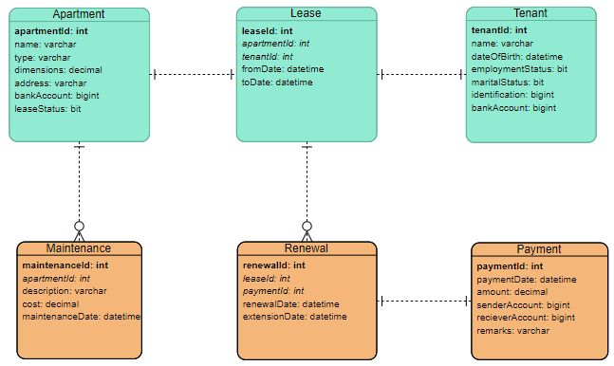

**DATA DICTIONARY:**

1. **Apartment:**

|  |  |  |
| --- | --- | --- |
| **Column** | **DataType** | **Description** |
| apartmentId | Int | Primary key |
| Name | Varchar | Name of the apartment |
| Type | Varchar | Type of the apartment |
| Dimensions | Decimal | Area of the apartment |
| Address | Varchar | Address of the apartment |
| bankAccount | Bigint | Bank account number of apartment owner |
| leaseStatus | Bit | Status of Lease, if apartment is already Leased leaseStatus is 1, else 0. |

1. **Lease:**

|  |  |  |
| --- | --- | --- |
| **Column** | **DataType** | **Description** |
| leaseId | Int | Primary key |
| apartmentId | Int | Foregin key |
| tenantId | Int | Foreign key |
| fromDate | Datetime | Start date of Lease |
| toDate | Datetime | End date of Lease |

1. **Tenant:**

|  |  |  |
| --- | --- | --- |
| **Column** | **DataType** | **Description** |
| tenantId | Int | Primary key |
| Name | Varchar | Full name of the Tenant |
| dateOfBirth | Datetime | Date of birth of the Tenant |
| employmentStatus | Bit | Employment Status of Tenant, if employed , value is 1 , else 0. |
| maritalStatus | Bit | Marital status of Tenant. If married, value is 1 , else 0. |
| Identification | Bigint | Personal Identification Number of Tenant |
| bankAccount | Bigint | Bank account number of Tenant |

1. **Renewal:**

|  |  |  |
| --- | --- | --- |
| **Column** | **DataType** | **Description** |
| renewalId | Int | Primary key |
| leaseId | Int | Foreign key |
| paymentId | Int | Foreign key |
| renewalDate | Datetime | Date of renewal |
| extensionDate | Datetime | Lease extension date. |

1. **Payment:**

|  |  |  |
| --- | --- | --- |
| **Column** | **DataType** | **Description** |
| paymentId | Int | Primary key |
| paymentDate | Datetime | Date of Payment |
| Amount | Decimal | Amount Paid |
| senderAccount | Bigint | Account number of Tenant |
| recieverAccount | Bigint | Account number of Apartment |
| Remarks | Varchar | Remarks if any. |

1. **Maintenance:**

|  |  |  |
| --- | --- | --- |
| **Column** | **DataType** | **Description** |
| maintenanceId | Int | Primary Key |
| apartmentId | Int | Foreign key |
| Description | Varchar | Description of maintenance |
| Cost | Decimal | Cost of maintenance |
| maintenanceDate | Datetime | Date of maintenance |

**SAMPLE QUERIES:**

1. Fetch details of all apartments which are available for Lease.

SQL Query:

select * from Apartment where leaseStatus=0

1. Fetch recent maintenance details of an apartment with id 123

SQL Query:

select * from Maintenance where apartmentId=123 order by maintenanceDate desc

1. Fetch Details of Tenant who lives in apartment with apartment id 123.

SQL Query:

select * from Tenant where tenantId in ( select tenantId from Lease where apartmentId=123)

**SCREENSHOTS OF TABLES:**

**Apartment table:**

**Creation of Apartment tables:**

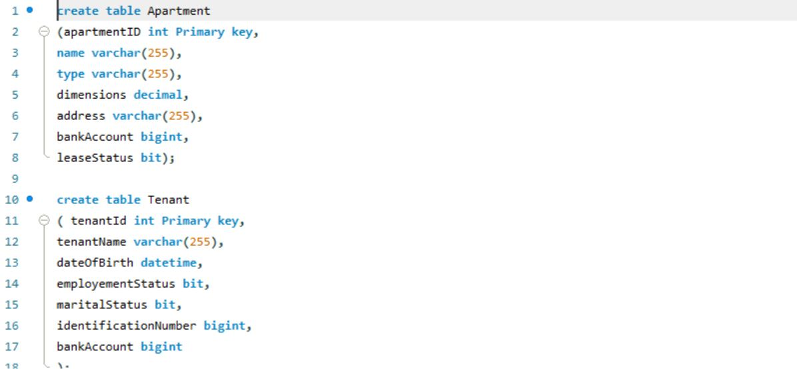

**Apartment table Screenshot:**

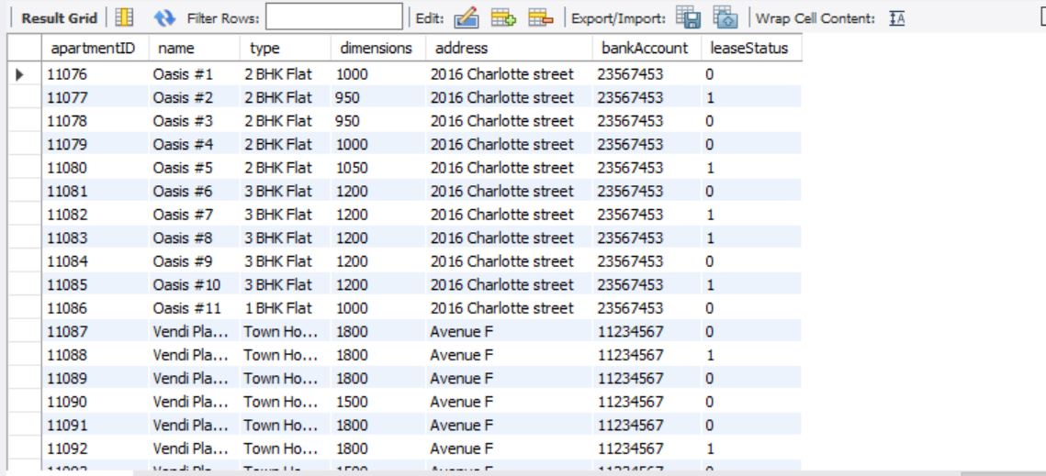

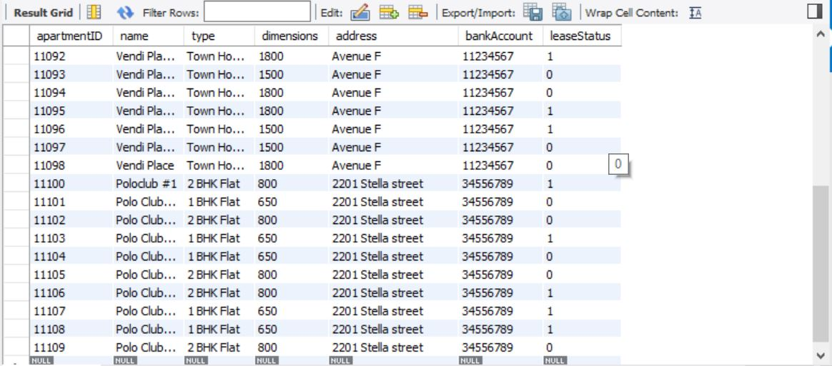

**Tenant table:**

**Creation of Tenant table:**



**Tenant table Screenshot:**

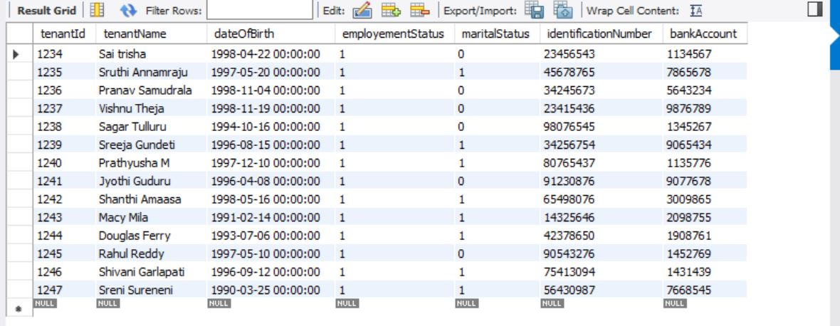

**Lease table:**

**Lease table creation:**

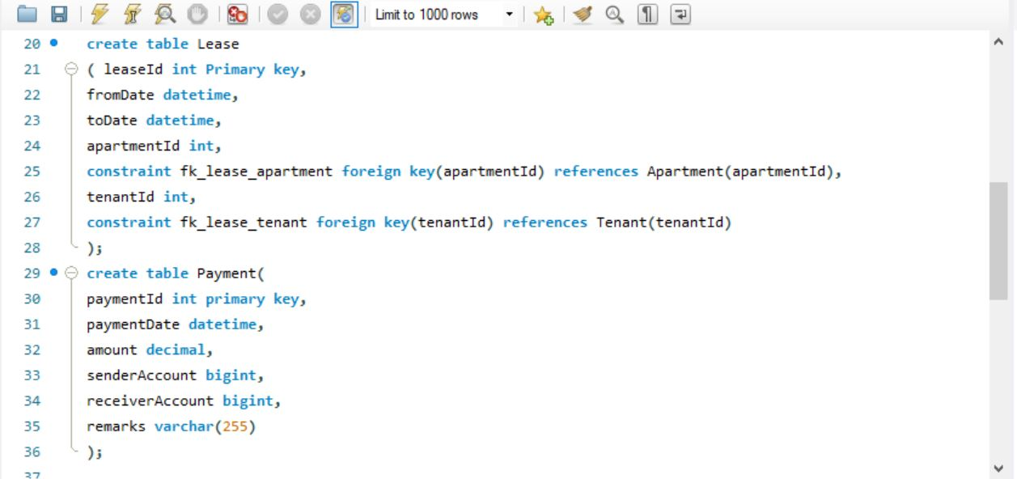

**Lease Table Screenshot**

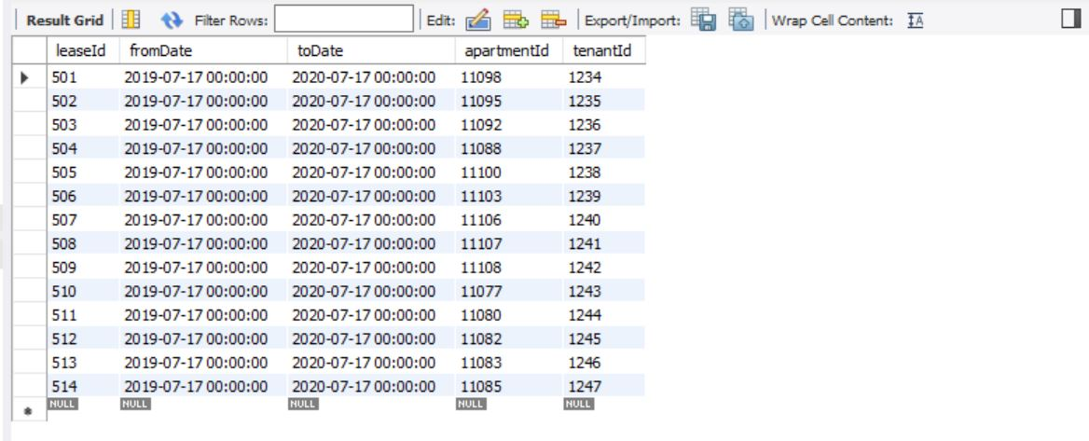

**Payment table**

**Payment table creation**



**Payment table screenshot:**

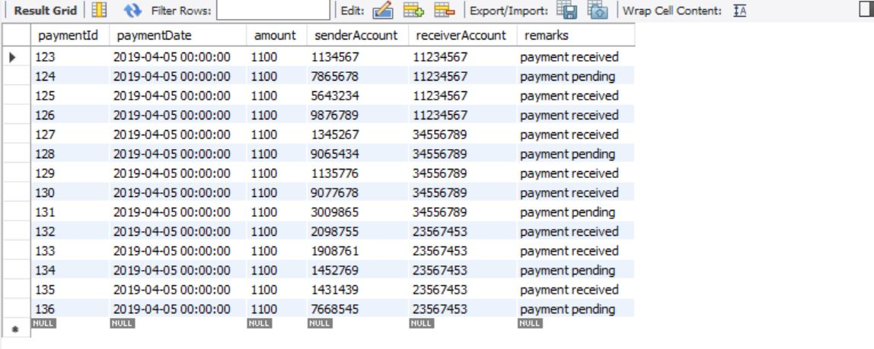

**Renewal table:**

**Renewal table creation:**

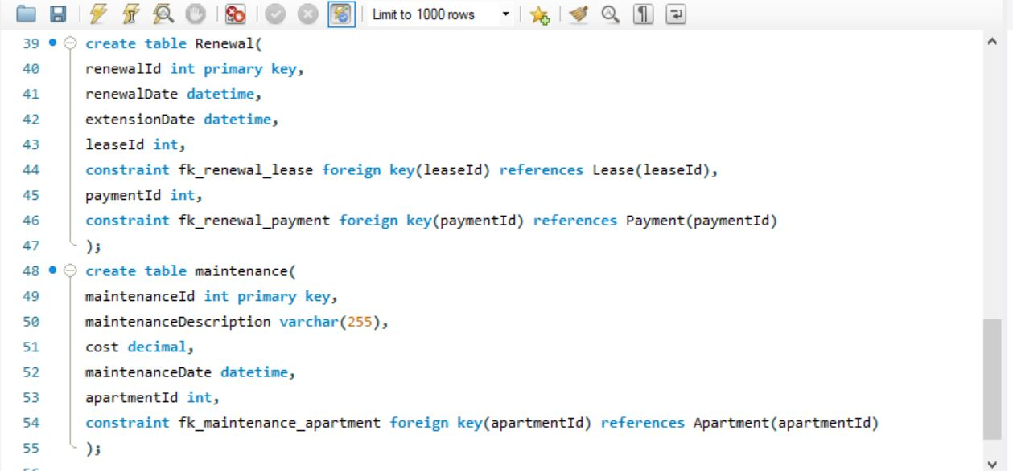

**Renewal table screenshot:**

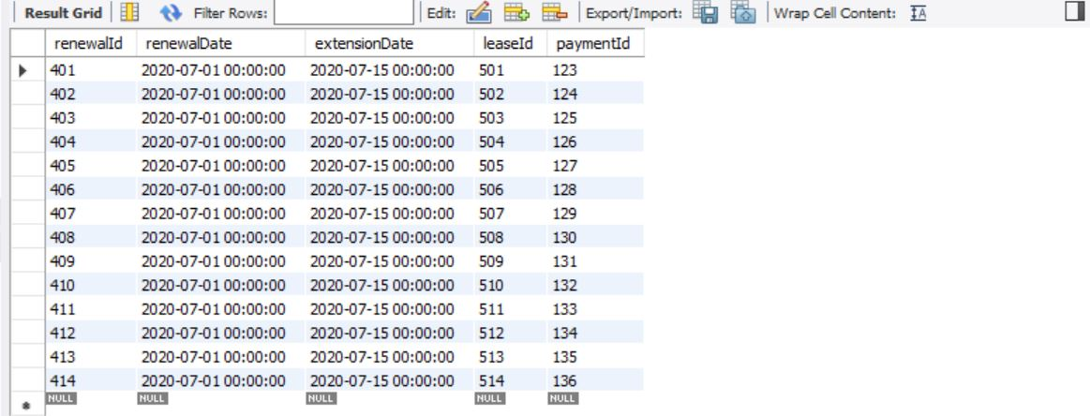

**Maintenance table**

**Maintenance table creation:**

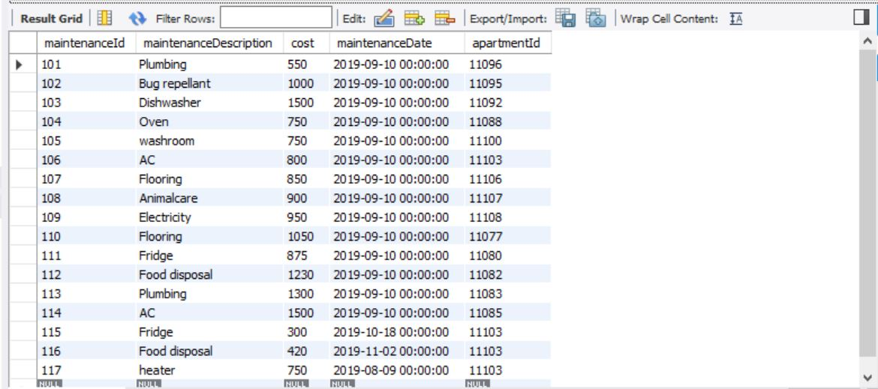

**Queries & Screenshots:**

1. All the apartments which are available for the lease?

Select* from apartment where leaseStatus=0;

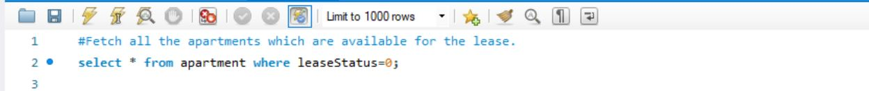

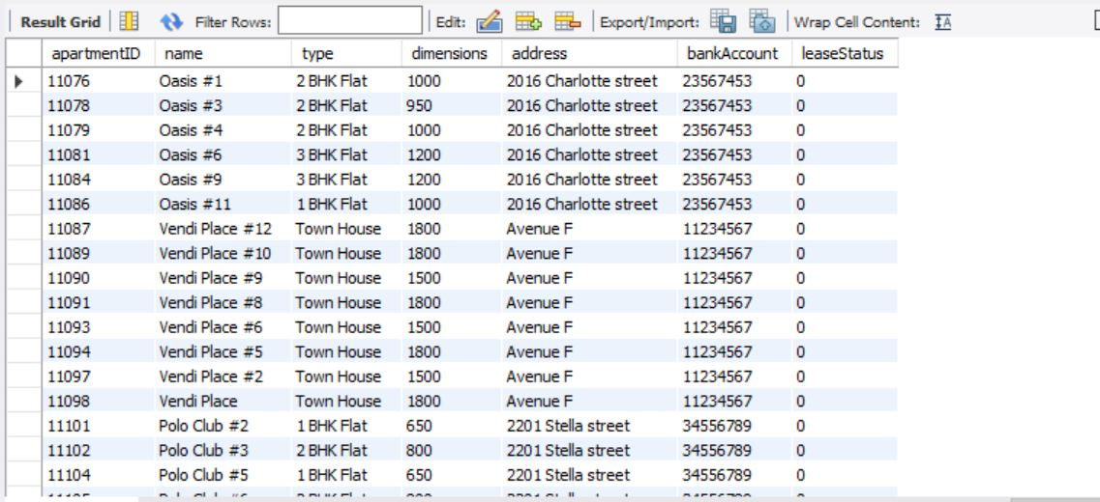

1. What are the maintenance details of apartment with apartment id 11103?

Select *from maintenance where apartmentid=11103 order by maintenancedate desc;

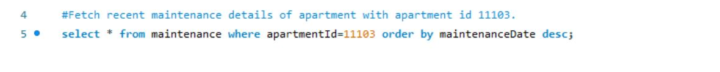

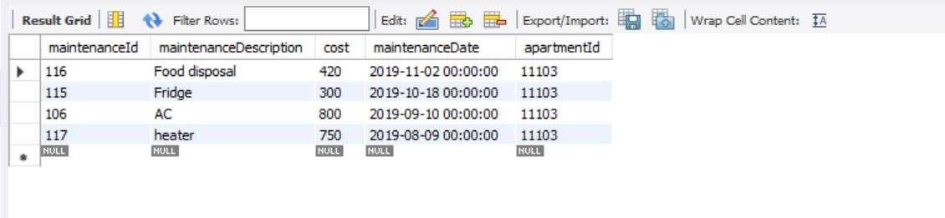

1. What are the details of the tenants who lives in the apartment with apartment id 11092?

Select t.* from tenanat t inner join Lease 1 on 1.enantId=t.tenant

Where 1.apartmentId=11092;

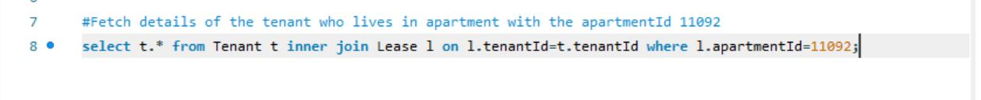**Tenant:**



1. All the details of tenants whose payment is pending?

Select t.* from Tenant t join Payment p on p.senderAccount=t.bankAccount where remarks like ‘%pending’;



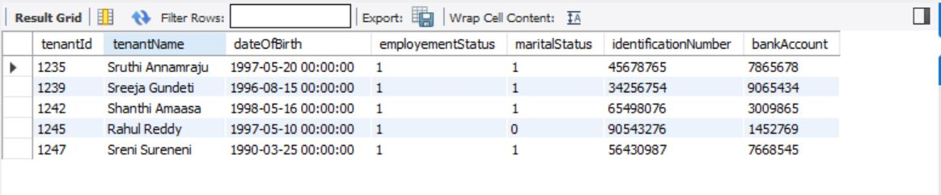

**Apartment:**

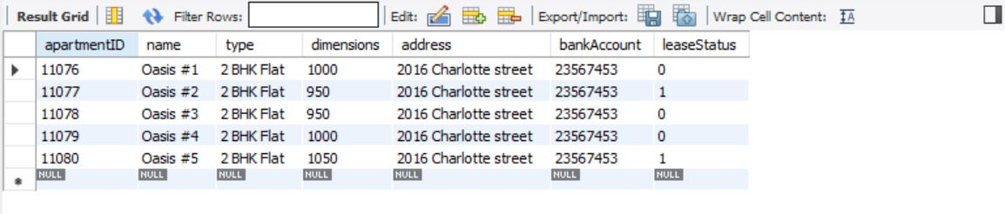

1. All the details of 2BHK apartments which have dimensions greater than 800sqft?

Select * from apartment where type like ‘2 BHK%’ AND dimensions>800;





1. What is the last date to renew the lease for the tenant id 1235?

Select toDate from Lease where tenantId=1235;



